Door Locker
Version 2.0

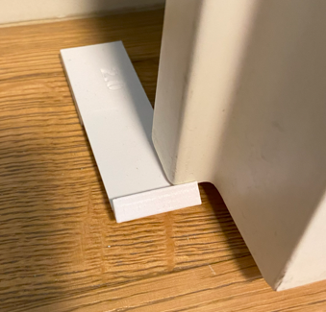

Project Goals
I wanted to stop indoor doors from banging because of the wind so I created a small hook that can be applied to the floor using double sided tape.
When the door is totally open the hook engage with the door rim, so the wind cannot move it.
But thanks to the flexibility of the hook it is easy to unlock it.

Door Locker Sketch

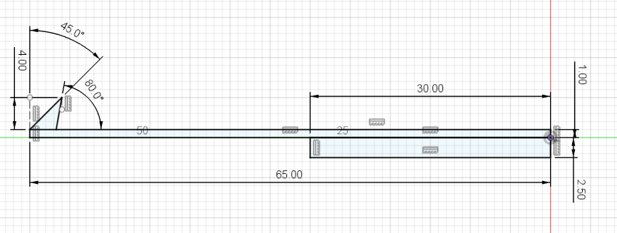

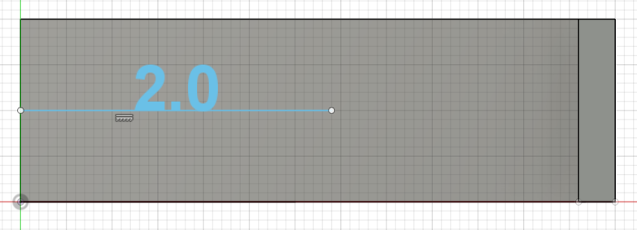

Door Locker 3D Model
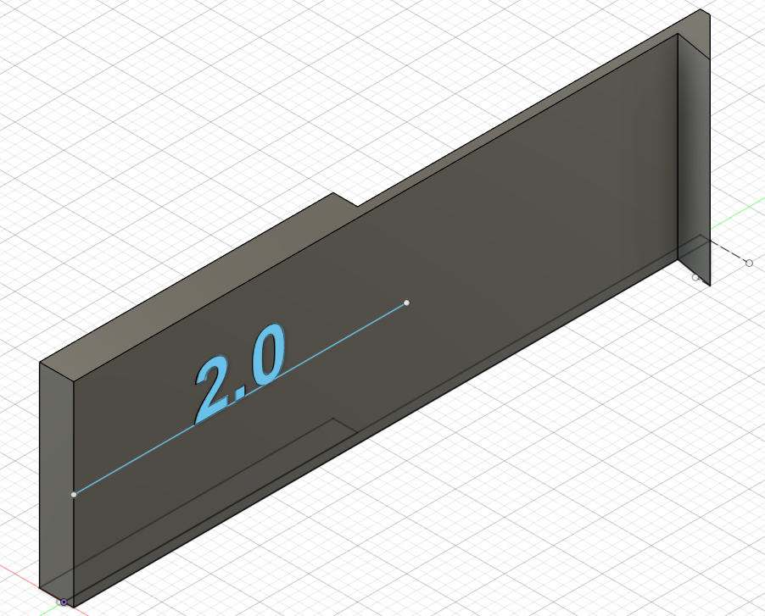

3D Printer Layout
Since the hook require some flexibility, best results are achievable using PETG-HF instead of PLA.
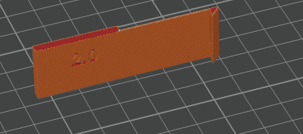

Final Result
